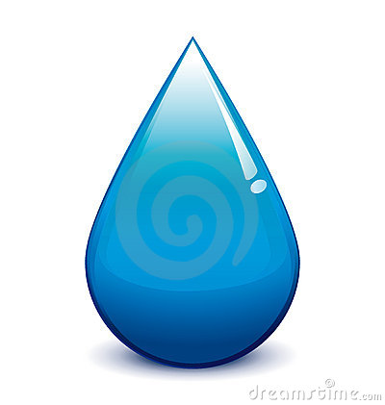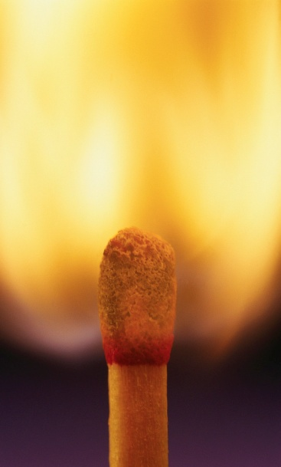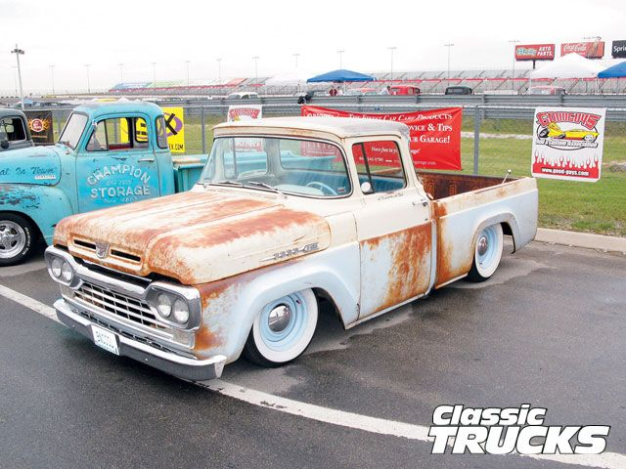

**e.g. Combustion**

**e.g.Corrosion**

**Oxidation:**

**Chemical Reaction Notes**

**Double Replacement**

**Single Replacement**

**Decomposition**

**Synthesis**

**A chemical reaction is:**