Topic 7 – Electricity in the Home

Name: _______________________ Date: ___________ Class: _______

- Can I identify similarities and differences between microelectronic circuits and circuits in a house?
- Can I assess the potential danger of electrical devices (voltage and amperage) and identify safe and unsafe practices?

Transmission of Electricity through the Power Grid

- Draw out the picture from pg. 318 and label it.

- What is the purpose of the transformers in the passing of electricity from a power station? _________________________________________________
___________________________________________________________

- What is the difference between a “step-up” and a “step-down” transformer?
________________________________________________________________________________________________________________________________

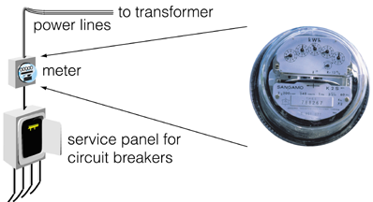From the Grid into Your Home

- What is the purpose of a power meter on your house? Explain.
_______________________________
_______________________________
_______________________________
_______________________________
_______________________________

- From the power meter, the electricity then goes to the _____________________. At the top of the panel, wires from the meter are connected to the main __________________.

- What is the purpose of the circuit breaker?
______________________________________________________________
______________________________________________________________

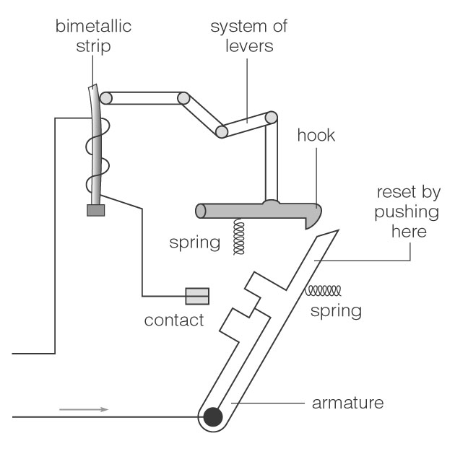
Circuit Breaker

In a circuit breaker, current flows through an armature, a contact, and a bimetallic strip (a strip made up of two different metals.) As the current increases, the temperature increases, and the metals begin to expand. One of the metals in the bimetallic strip expands faster than the other, causing the strip to bend. As the strip bends away from the system of levers, the connection is broken and the hook releases the armature, breaking the contact.

- Older homes have fuse boxes. What is the purpose of a fuse?
________________________________________________________________________________________________________________________________

Fuse
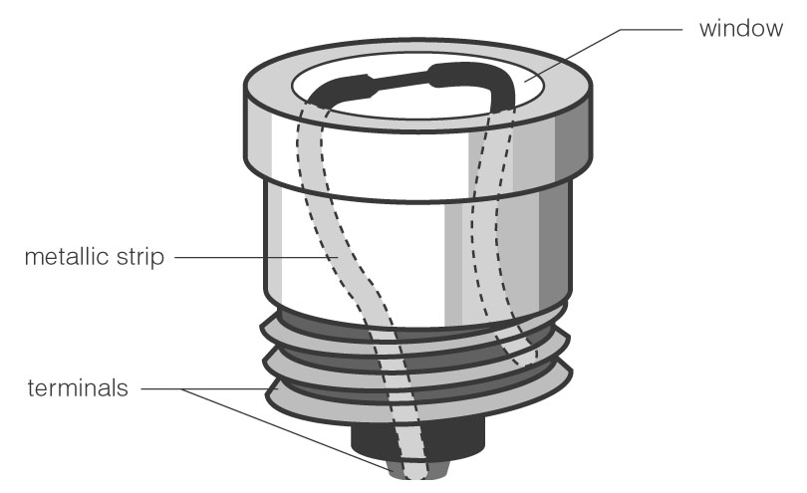
portion of the
conductor melts when it gets too hot

A fuse acts like a switch. The fuse contains a metallic strip with a relatively low melting point. This strip melts when too much current flows through it, resulting in a gap through which current cannot flow.

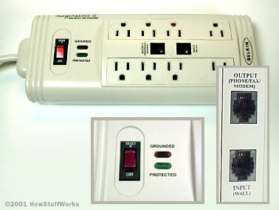
- What is the purpose of a surge protector?(p. 322) _______________________
_______________________________________________________________

- The electricity is then spread out through your house by the means
of a _______________________. How are branch circuits connected in a household? __________________________________________

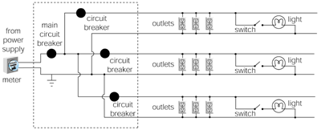


- The breaker, plugs, lights and switches in each branch circuit are connected by electrical cables with three wires.
 | Color | Purpose

Neutral Wire

Live Wires
Hot Wire
Ground Wire

a. What is the potential difference (voltage) for ordinary appliances? __________
b. What is the potential difference (voltage) for stoves, ovens and dryers? ____________

- Why do you need to get an Electrical Code for your house?
________________________________________________________________________________________________________________________________

Digital Device (Pg. 322)

- What is the purpose of Digital Electronic Devices? ______________________________________________________________
______________________________________________________________

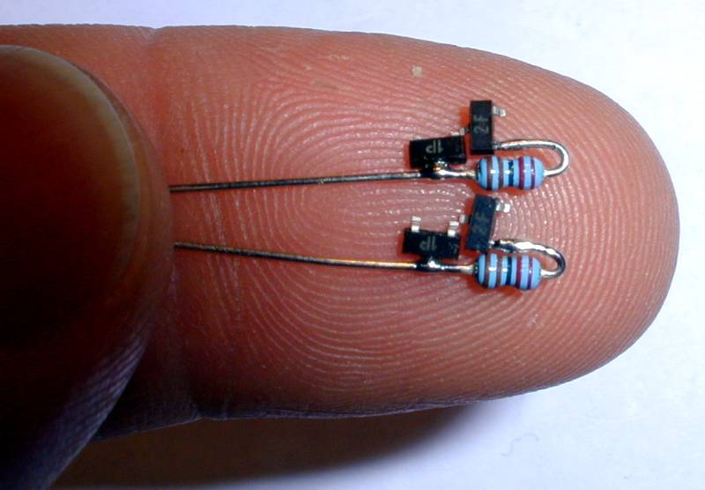
- Modern devices need to be controlled
by microscopic, electronic switches.
What are these switches called and how
do they work? _________________
_____________________________
_____________________________
_____________________________
_____________________________
_____________________________

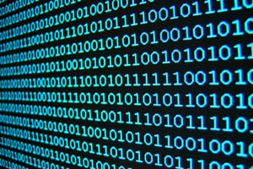
- These switches can then be represent by numbers and letters using a _____________________ which is represented by zeros and ones (001110110001)

Measuring Electric Power

Name: _________________ Date: _________ Class: ________

General Outcome #3: Examine the power and efficiency of various devices.
- Can I calculate the amount of energy that a device uses?
- Can I apply the concepts of conservation of energy and efficiency to different devices?

ELECTRIC POWER is the amount of electric energy that is converted into other forms of energy (heat, light, sound, or motion) every second.

-the symbol for power is P
-Power is measured in WATTS (W)

Can be measured two ways:
- Power (Watts) = Energy (in Joules) P = E
Time (in seconds) t

-or-

- Power (Watts) = Current (Amps) X Voltage (Volts) P = I x V

*One watt is a small amount of electric power. Usually, watts will be converted into kilowatts (kW) by dividing watts by 1000.
1000W = 1KW

- 1430 watts = ___________kW
- 12350 watts = ___________kW

E.g. A current of 13.6A passes through an electric heater when it is connected to a 100V wall outlet. What is the power of the heater?

E.g. If the voltage across a device is 100V and the power that the object uses is 1200W, what is the current that is running in the circuit?

Paying for Electrical Energy

-producing and distributing electricity can get expensive

-power companies charge the consumer for the amount of wattage used each hour

-the units that power companies use to measure the electricity is called a
Kilowatt hour (kW∙hr)

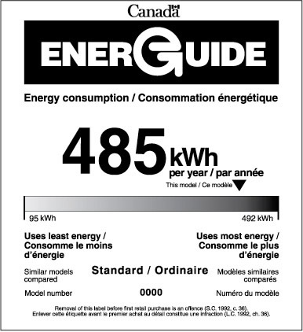

E.g. A ceiling fan will use 300W of power to function. If you use the fan for 3 hours a day over a 30 day period, and the cost per kW∙h is 11 cents, how much will it cost you to run the ceiling fan?


