**Above the Atmosphere and Under Control**

Topic 6 pp. 402-407

# Clarifying Images (p. 402)

1. What does CCD stand for? \_\_\_\_\_\_\_\_\_\_\_\_\_\_\_\_\_\_\_\_\_\_\_\_\_\_\_\_\_\_\_\_\_\_\_\_

(*A CCD is the same thing that digital cameras use instead of film!)*

2. What do these types of cameras use instead of photographic plates (film) to develop their pictures on?

\_\_\_\_\_\_\_\_\_\_\_\_\_\_\_\_\_\_\_\_\_\_\_\_\_\_\_\_\_\_\_\_\_\_\_\_\_\_\_\_\_\_\_\_\_\_\_\_\_\_\_\_\_\_\_\_\_\_\_\_\_\_\_\_\_\_\_\_\_

\_\_\_\_\_\_\_\_\_\_\_\_\_\_\_\_\_\_\_\_\_\_\_\_\_\_\_\_\_\_\_\_\_\_\_\_\_\_\_\_\_\_\_\_\_\_\_\_\_\_\_\_\_\_\_\_\_\_\_\_\_\_\_\_\_\_\_\_\_

3. What are some benefits to this process?

\_\_\_\_\_\_\_\_\_\_\_\_\_\_\_\_\_\_\_\_\_\_\_\_\_\_\_\_\_\_\_\_\_\_\_\_\_\_\_\_\_\_\_\_\_\_\_\_\_\_\_\_\_\_\_\_\_\_\_\_\_\_\_\_\_\_\_\_\_\_\_\_\_\_\_\_\_\_\_\_\_\_\_\_\_\_\_\_\_\_\_\_\_\_\_\_\_\_\_\_\_\_\_\_\_\_\_\_\_\_\_\_\_\_\_\_\_\_\_\_\_\_\_\_\_\_\_\_\_\_\_\_\_\_\_\_\_\_

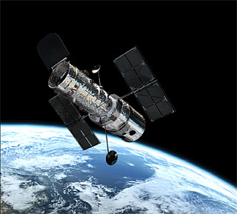**Looking At the Earth (p. 403)**

4. The Hubble Space Telescope is a great example of how rocketry and computers are being used for further space exploration. Although it is a telescope, it is also referred to as an artificial satellite. Why is it called this?

\_\_\_\_\_\_\_\_\_\_\_\_\_\_\_\_\_\_\_\_\_\_\_\_\_\_\_\_\_\_\_\_\_\_\_

\_\_\_\_\_\_\_\_\_\_\_\_\_\_\_\_\_\_\_\_\_\_\_\_\_\_\_\_\_\_\_\_\_\_\_

\_\_\_\_\_\_\_\_\_\_\_\_\_\_\_\_\_\_\_\_\_\_\_\_\_\_\_\_\_\_\_\_\_\_\_

\_\_\_\_\_\_\_\_\_\_\_\_\_\_\_\_\_\_\_\_\_\_\_\_\_\_\_\_\_\_\_\_\_\_\_

5. What is a natural occurring satellite? Why is this different than an artificial satellite?

\_\_\_\_\_\_\_\_\_\_\_\_\_\_\_\_\_\_\_\_\_\_\_\_\_\_\_\_\_\_\_\_\_\_\_\_\_\_\_\_\_\_\_\_\_\_\_\_\_\_\_\_\_\_\_\_\_\_\_\_\_\_\_\_\_\_\_\_\_\_\_\_\_\_\_\_\_\_\_\_\_\_\_\_\_\_\_\_\_\_\_\_\_\_\_\_\_\_\_\_\_\_\_\_\_\_\_\_\_\_\_\_\_\_\_\_\_\_\_\_\_\_\_\_\_\_\_\_\_\_\_\_\_\_\_\_\_\_

6. If the moon is a satellite of Earth, is the Earth the satellite of some celestial object? Explain your answer.

\_\_\_\_\_\_\_\_\_\_\_\_\_\_\_\_\_\_\_\_\_\_\_\_\_\_\_\_\_\_\_\_\_\_\_\_\_\_\_\_\_\_\_\_\_\_\_\_\_\_\_\_\_\_\_\_\_\_\_\_\_\_\_\_\_\_\_\_\_

BS00542_**Communication Satellites (p. 404)**

7.In order to increase communication and data across the globe, communication satellites have enabled us to send information almost instantly. Communication satellites are put into two different types of orbits. Describe the two orbits.

Orbit 1: \_\_\_\_\_\_\_\_\_\_\_\_\_\_\_\_\_\_\_\_\_\_\_\_\_: (see figure 5.46) \_\_\_\_\_\_\_\_\_\_\_\_\_\_\_\_\_\_\_\_\_\_\_\_\_\_\_\_\_\_\_\_\_\_\_\_\_\_\_\_\_\_\_\_\_\_\_\_\_\_\_\_\_\_\_\_\_\_\_\_\_\_\_\_\_\_\_\_\_\_\_\_\_\_\_\_\_\_\_\_\_\_\_\_\_\_\_\_\_\_\_\_\_\_\_\_\_\_\_\_\_\_\_\_\_\_\_\_\_\_\_\_\_\_\_\_\_\_\_\_\_\_\_\_\_\_\_\_\_\_\_\_\_\_\_\_\_\_

\_\_\_\_\_\_\_\_\_\_\_\_\_\_\_\_\_\_\_\_\_\_\_\_\_\_\_\_\_\_\_\_\_\_\_\_\_\_\_\_\_\_\_\_\_\_\_\_\_\_\_\_\_\_\_\_\_\_\_\_\_\_\_\_\_\_\_\_\_

Orbit 2: \_\_\_\_\_\_\_\_\_\_\_\_\_\_\_\_\_\_\_\_\_\_\_\_\_: (see figure 5.46) \_\_\_\_\_\_\_\_\_\_\_\_\_\_\_\_\_\_\_\_\_\_\_\_\_\_\_\_\_\_\_\_\_\_\_\_\_\_\_\_\_\_\_\_\_\_\_\_\_\_\_\_\_\_\_\_\_\_\_\_\_\_\_\_\_\_\_\_\_\_\_\_\_\_\_\_\_\_\_\_\_\_\_\_\_\_\_\_\_\_\_\_\_\_\_\_\_\_\_\_\_\_\_\_\_\_\_\_\_\_\_\_\_\_\_\_\_\_\_\_\_\_\_\_\_\_\_\_\_\_\_\_\_\_\_\_\_\_\_\_\_\_\_\_\_\_\_\_\_\_\_\_\_\_\_\_\_\_\_\_\_\_\_\_\_\_\_\_\_\_\_\_\_\_\_\_\_\_\_\_\_\_\_\_\_\_\_\_\_\_\_\_\_\_\_\_\_\_\_\_\_\_\_\_\_\_\_

Draw the two orbits in relation to the Earth. Label your drawing. (See p. 404)

8. How could you tell if a satellite dish was tracking a geosynchronous satellite? \_\_\_\_\_\_\_\_\_\_\_\_\_\_\_\_\_\_\_\_\_\_\_\_\_\_\_\_\_\_\_\_\_\_\_\_\_\_\_\_\_\_\_\_\_\_\_\_\_\_\_\_\_\_\_\_\_\_\_\_\_\_\_\_\_\_\_\_\_\_\_\_\_\_\_\_\_\_\_\_\_\_\_\_\_\_\_\_\_\_\_\_\_\_\_\_\_\_\_\_\_\_\_\_\_\_\_\_\_\_\_\_\_\_\_\_\_\_\_\_\_\_\_\_\_\_\_\_\_\_\_\_\_\_\_\_\_\_

9. A company wants to put a fleet of low Earth satellites in orbit to create a worldwide telephone link. What is the benefit of doing this instead of putting their satellites in a geosynchronous orbit?

\_\_\_\_\_\_\_\_\_\_\_\_\_\_\_\_\_\_\_\_\_\_\_\_\_\_\_\_\_\_\_\_\_\_\_\_\_\_\_\_\_\_\_\_\_\_\_\_\_\_\_\_\_\_\_\_\_\_\_\_\_\_\_\_\_\_\_\_\_\_\_\_\_\_\_\_\_\_\_\_\_\_\_\_\_\_\_\_\_\_\_\_\_\_\_\_\_\_\_\_\_\_\_\_\_\_\_\_\_\_\_\_\_\_\_\_\_\_\_\_\_\_\_\_\_\_\_\_\_\_\_\_\_\_\_\_\_\_\_\_\_\_\_\_\_\_\_\_\_\_\_\_\_\_\_\_\_\_\_\_\_\_\_\_\_\_\_\_\_\_\_\_\_\_\_\_\_\_\_\_\_\_\_\_\_\_\_\_\_\_\_\_\_\_\_\_\_\_\_\_\_\_\_\_\_\_\_\_\_\_\_\_\_\_\_\_\_\_\_\_\_\_\_\_\_\_\_\_\_\_\_\_\_\_\_\_\_\_\_\_\_\_\_\_\_\_\_\_\_\_\_\_\_\_\_\_\_\_\_\_\_\_\_\_\_\_\_\_\_\_\_\_\_\_\_\_\_\_\_\_

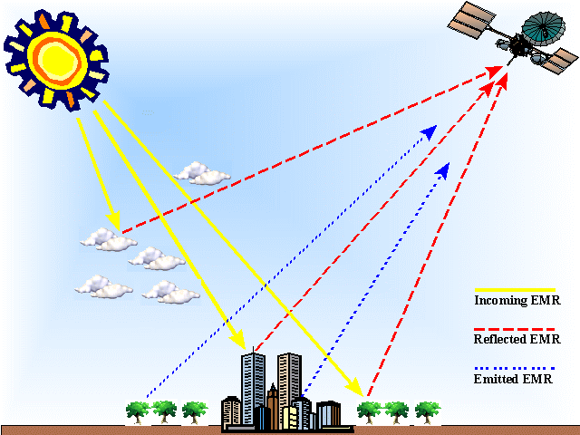10. a) What is remote sensing?

b) What are four applications that can be

done using remote sensing?

1. \_\_\_\_\_\_\_\_\_\_\_\_\_\_\_\_\_\_\_\_\_\_\_\_\_\_\_\_\_\_\_\_\_\_\_\_\_\_\_\_\_\_\_\_\_\_\_\_\_\_\_\_\_\_\_\_\_\_\_\_\_

2. \_\_\_\_\_\_\_\_\_\_\_\_\_\_\_\_\_\_\_\_\_\_\_\_\_\_\_\_\_\_\_\_\_\_\_\_\_\_\_\_\_\_\_\_\_\_\_\_\_\_\_\_\_\_\_\_\_\_\_\_\_

3. \_\_\_\_\_\_\_\_\_\_\_\_\_\_\_\_\_\_\_\_\_\_\_\_\_\_\_\_\_\_\_\_\_\_\_\_\_\_\_\_\_\_\_\_\_\_\_\_\_\_\_\_\_\_\_\_\_\_\_\_\_\_

4. \_\_\_\_\_\_\_\_\_\_\_\_\_\_\_\_\_\_\_\_\_\_\_\_\_\_\_\_\_\_\_\_\_\_\_\_\_\_\_\_\_\_\_\_\_\_\_\_\_\_\_\_\_\_\_\_\_\_\_\_\_

**Global Positioning Systems (GPS) (p. 407)**

11. What is a Global Positioning Unit?

\_\_\_\_\_\_\_\_\_\_\_\_\_\_\_\_\_\_\_\_\_\_\_\_\_\_\_\_\_\_\_\_\_\_\_\_\_\_\_\_\_\_\_\_\_\_\_\_\_\_\_\_\_\_\_\_\_\_\_\_\_\_\_\_\_\_\_\_\_\_\_\_\_\_\_\_\_\_\_\_\_\_\_\_\_\_\_\_\_\_\_\_\_\_\_\_\_\_\_\_\_\_\_\_\_\_\_\_\_\_\_\_\_\_\_\_\_\_\_\_\_\_\_\_\_\_\_\_\_\_\_\_\_\_\_\_\_\_

12. What type of orbit are GPS satellites in? Describe.

\_\_\_\_\_\_\_\_\_\_\_\_\_\_\_\_\_\_\_\_\_\_\_\_\_\_\_\_\_\_\_\_\_\_\_\_\_\_\_\_\_\_\_\_\_\_\_\_\_\_\_\_\_\_\_\_\_\_\_\_\_\_\_\_\_\_\_\_\_\_\_\_\_\_\_\_\_\_\_\_\_\_\_\_\_\_\_\_\_\_\_\_\_\_\_\_\_\_\_\_\_\_\_\_\_\_\_\_\_\_\_\_\_\_\_\_\_\_\_\_\_\_\_\_\_\_\_\_\_\_\_\_\_\_\_\_\_\_\_\_\_\_\_\_\_\_\_\_\_\_\_\_\_\_\_\_\_\_\_\_\_\_\_\_\_\_\_\_\_\_\_\_\_\_\_\_\_\_\_\_\_\_\_\_\_\_\_\_\_\_\_\_\_\_\_\_\_\_\_\_\_\_\_\_\_\_\_

13. a) How does a GPS find locate a person on Earth? Explain.

\_\_\_\_\_\_\_\_\_\_\_\_\_\_\_\_\_\_\_\_\_\_\_\_\_\_\_\_\_\_\_\_\_\_\_\_\_\_\_\_\_\_\_\_\_\_\_\_\_\_\_\_\_\_\_\_\_\_\_\_\_\_\_\_\_\_\_\_\_\_\_\_\_\_\_\_\_\_\_\_\_\_\_\_\_\_\_\_\_\_\_\_\_\_\_\_\_\_\_\_\_\_\_\_\_\_\_\_\_\_\_\_\_\_\_\_\_\_\_\_\_\_\_\_\_\_\_\_\_\_\_\_\_\_\_\_\_\_\_\_\_\_\_\_\_\_\_\_\_\_\_\_\_\_\_\_\_\_\_\_\_\_\_\_\_\_\_\_\_\_\_\_\_\_\_\_\_\_\_\_\_\_\_\_\_\_\_\_\_\_\_\_\_\_\_\_\_\_\_\_\_\_\_\_\_\_\_

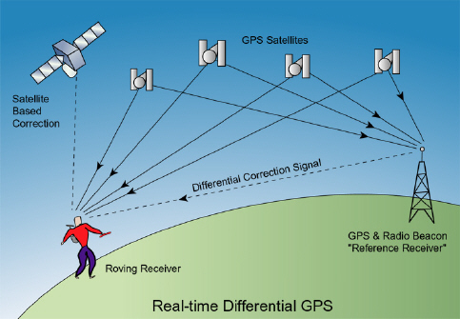

b) How close can they find a position using a GPS?

\_\_\_\_\_\_\_\_\_\_\_\_\_\_\_\_\_\_\_\_\_\_\_\_\_\_\_\_\_\_\_\_\_\_\_\_\_\_\_\_\_