# Topic 4 - Different Kinds of Elements

**Name: ___________________ Date: ________________ Class: ____**

## General Outcome: Describe the chemical nature of elements.

* *Can I understand the origins of the periodic table and relate patterns in the physical and chemical properties of elements to their positions in the periodic table?*

1. One way of classifying elements is to sort them into *metals*, *non-metals*, and *metalloids.* Complete the following table using table 2.3 found on pg. 118.

|  |  |  |  |  |
| --- | --- | --- | --- | --- |
|  | **State at room temperature** | **Appearance** | **Conductivity** | **Malleability and Ductility** |
| Metals |  |  |  |  |
| **Non-Metals** |  |  |  |  |
| **Metalloids** |  |  |  |  |

### Properties of Metals, Non-Metals, and Metalloids

2. What does malleability mean? (see page 104 for help)

3. What does ductile mean? (see page 104 for help)

5. On the following periodic table, color the metals ORANGE, the metalloids RED, and the non-metals YELLOW.

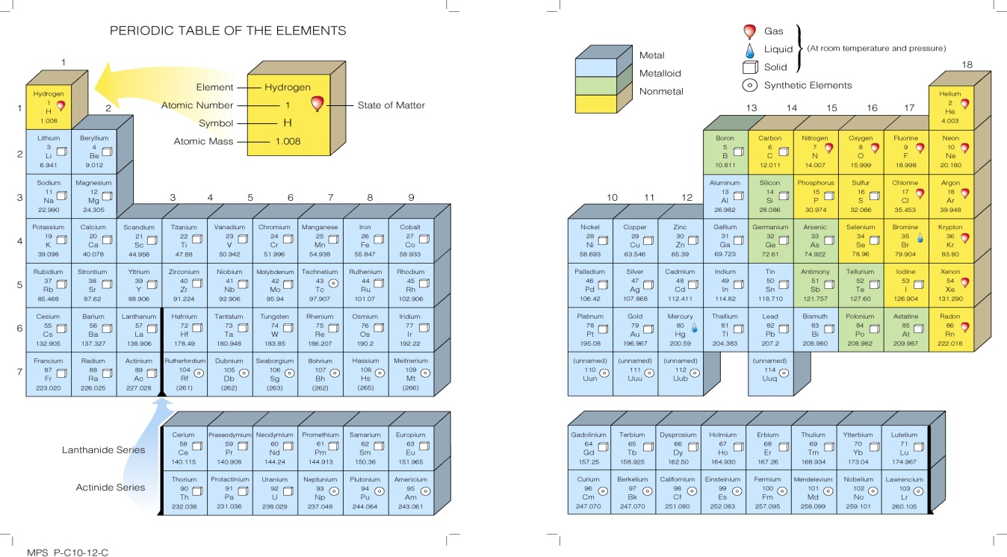

6. What is a Chemical Family?

### Use the table found on Pg. 120 to help you answer the following questions. Be specific!!

7. Gold, Silver and Copper were once used to make coins. Why were these

metals beneficial for this purpose? List three reasons from the chart.

8. Although Aluminum (Al) and Iron (Fe) have some similar characteristics to

Gold, Copper, and Silver, why do you think they are not considered to be in

the same Chemical Family? Explain.

9. Do you think that aluminum belongs to the same chemical family as iron?

List arguments for and against.

|  |  |
| --- | --- |
| **Arguments For** | **Arguments Against** |
|  |  |

j0240329

**4 Major Chemical Families**

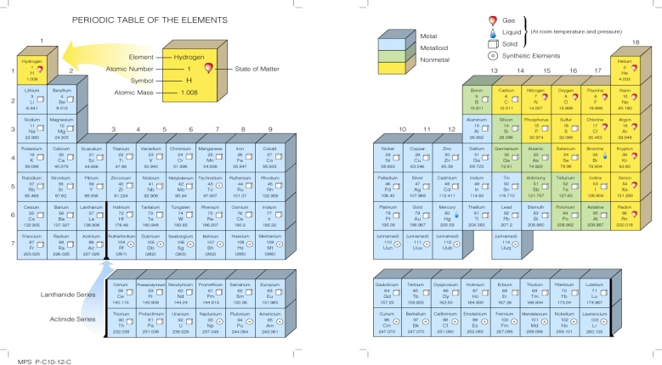

**1. Alkali Metals**

Colour this family green.

-incredibly __________________

-all have ____________________

____________________________

____________________________

-require special storage

*Draw out the atoms of the following elements that belong to Alkali Metals:*

Lithium Sodium





**2. Alkaline Earth Metals**

Colour this family light blue.

-reactive but ___________________

______________________________

-all have _______________________

_______________________________ (harder to get rid of two than

one electron so they don’t react as quickly

*Draw out the atoms of the following elements that belong to Alkaline Earth Metals:*

 Beryllium Magnesium

**3. Halogens**

Colour this family pink.

-react ______________with almost

every other element

-unlike alkali, halogens react strongly

because they are _________________

________________________________

-extremely corrosive and harmful

*Draw out the atoms of the following elements that belong to Halogens:*

 Flourine Chlroine



**4. Noble Gases**

Colour this family dark blue.

-all are _____________(unreactive)

-each element has a full shell so it

will not react with anything

-will exist in nature as _______________ ONLY

*Draw out the atoms of the following elements that belong to Noble Gases:*

 Helium Neon Argon