The Spectroscope: Meanings in Light
(Topic 3)

Now that astronomers could gaze deeper into the universe using simple telescopes, they faced a new challenge – the stars? What were they made of?

Spectral Lines (p. 376)

Isacc Newton passed a beam of sunlight through a _________________. When he did this, it produced a ____________________________. What did he conclude that white light is made up of? ___________________________________________________________________________________

A device that creates a fine (detailed) spectrum is called a ________________________________.

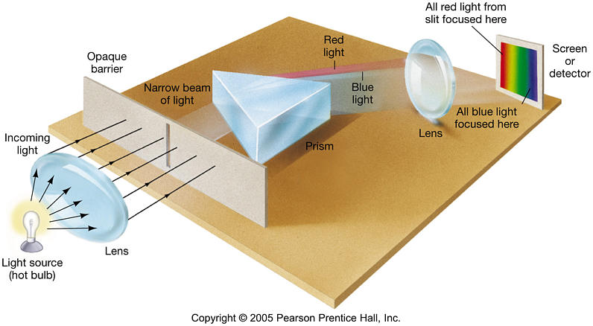

When we look at the Sun’s light through these devices, they noticed that there were a lot of small lines of missing light in the Sun’s spectrum. These dark lines are called ____________________.

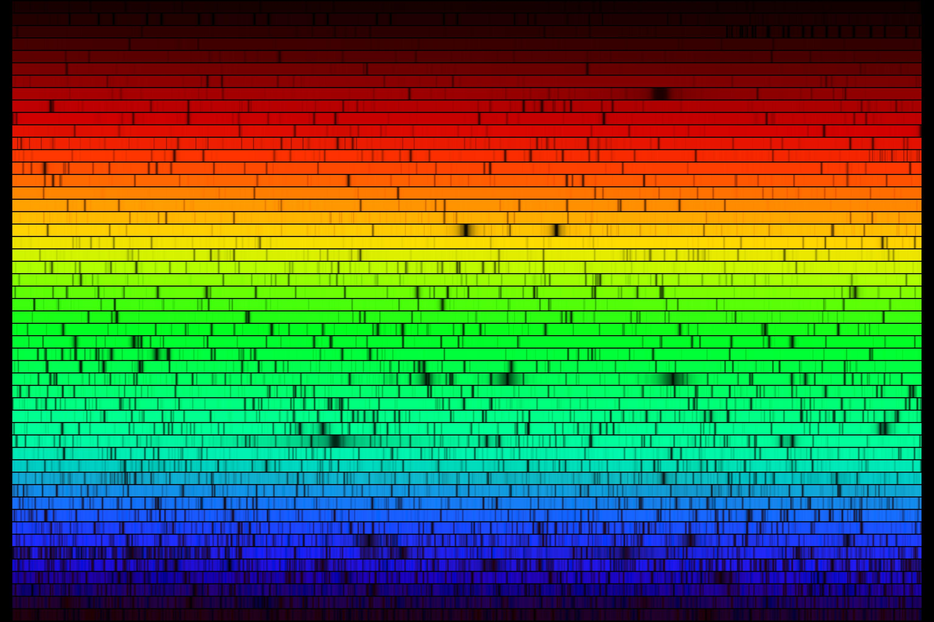

They were able to map out the lines but they didn’t know what the lines were or what caused them.

Spectroscopy: The Science of Color (p. 377)
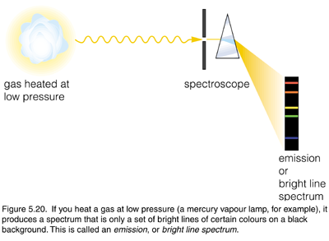
Three Types of Spectra:

- Emission (Bright Line) Spectrum

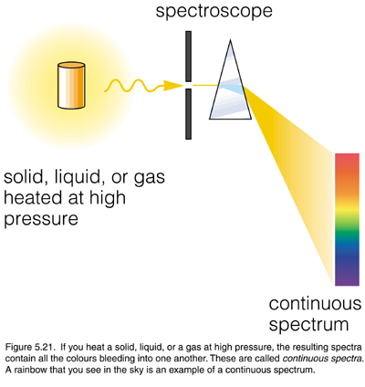
- Continuous spectrum

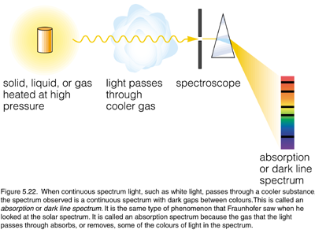

- Absorption (Dark Line) Spectrum

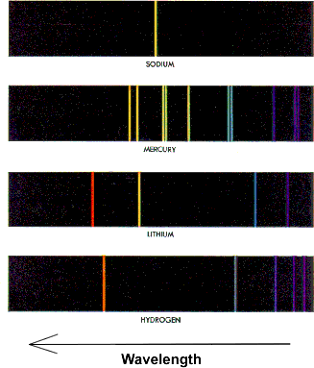

Each of the following bright line spectra represents a different element.

Each line will be unique to that element so if we can find the correct lines, we can tell what a star is made up of.

To identify what gases are in a star, scientists study the position of the spectral lines.

Diffraction Gratings (p. 378)
Explain how a Diffraction Grating works. __________________________________________________
______________________________________________________________________________________________________________________________________________________________________

Why do we tend to use diffracting gratings than prisms? ______________________________________
___________________________________________________________________________________

Spectroscopy for Astronomers (p. 380)
Why do we often compare the spectral lines that are given off by excited gas to a person’s finger prints? ___________________________________________________________________________________
______________________________________________________________________________________________________________________________________________________________________

What did scientists start to conclude about dark line (absorption) spectrum that was being produced by the Sun? ___________________________________________________________________________
______________________________________________________________________________________________________________________________________________________________________

The process in which we match up the dark lines in a solar spectrum to match the bright lines produced by various elements is known as _____________________.

Long Distance Chemistry (p. 381)
In this investigation, you have an opportunity to apply the method that astronomers use to detect the chemical make-up of a star. Examine the simplified spectra of five known chemical elements and use that information to interpret the composition of the Sun and three “mystery stars”.
1. Which elements are present in the sun’s spectrum?

2. In which two mystery stars is calcium present?

3. Which mystery star contains Na?

4. Only one star contains Hg. Which one is it?

5. Which mystery star’s composition is MOST like that of our Sun?

Glue in p. 381 spectrum

Name: _____________________________________ Date: __________________________

Analyzing Spectral Patterns

Outcome:
Can I analyze spectral patterns in order to understand how radio telescopes are used in determining characteristics of stars and star systems?

What to Do
Analyze the spectra below in order to answer the following questions.

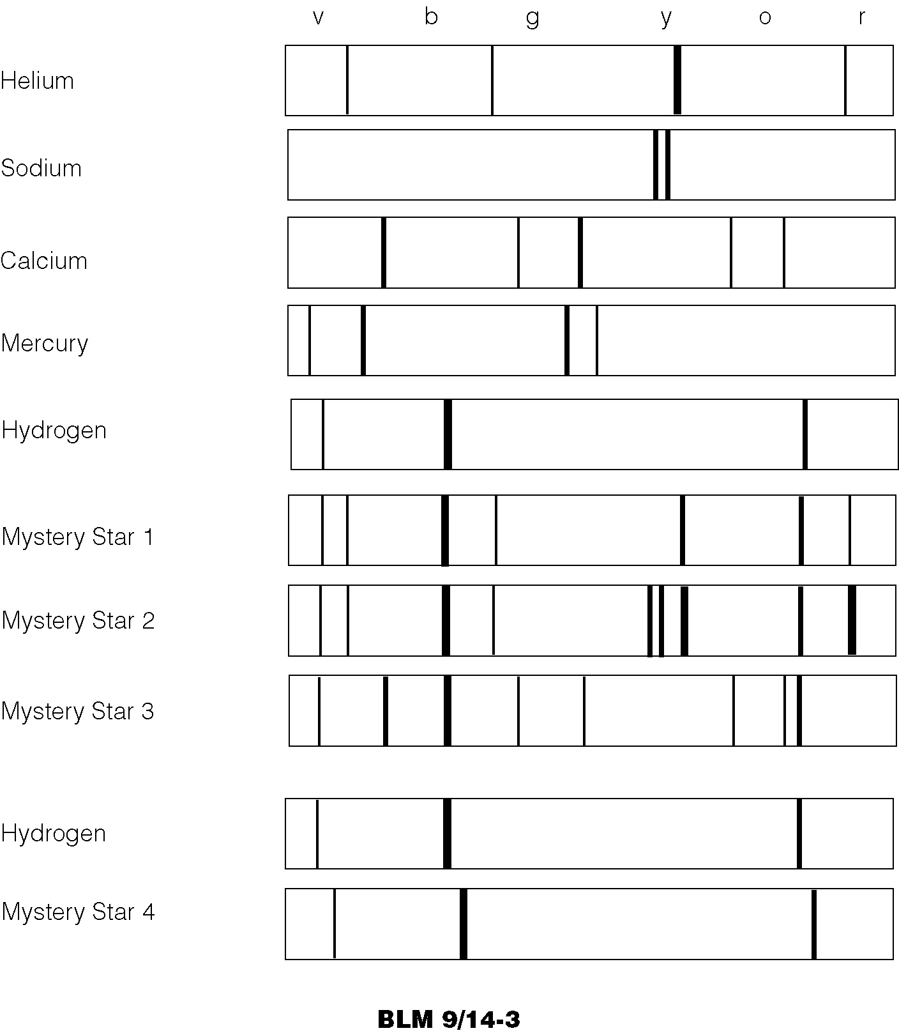

Questions

Use the space below to write answers to the questions.
2. (a) There is something strange about
Mystery Star 4’s spectrum. What
chemical is in Mystery Star 4?

- What is odd about the spectrum?

_______________________________
_______________________________

- List the chemical elements in:
- Mystery Star 1

- Mystery Star 2

- Mystery Star 3

_______________________________

The Doppler Effect (p. 382)

Spectroscopes not only tell us what a star could be made up of but can also tell us ____________________________________________________________________

What is the Doppler effect? _______________________________________________
____________________________________________________________________________________________________________________________________________

As a vehicle approaches you, what happens to the wavelength of the sound wave and how would it hear to your ear? ______________________________________________
______________________________________________________________________

As a vehicle passes you, what happens to its wavelength and now how would it sound like? __________________________________________________________________
______________________________________________________________________

Use the space below to draw a picture that shows this effect.

Light waves behave much like sound waves. As an object that gives off light comes toward us, the light waves can also be compress, or when it moves away from us, the light waves can be elongated.

What happens to the star’s light when the star is approaching us? (moving towards Earth)? _______________________________________________________________
_____________________________________________________________________

What would happen to its Spectral Lines? (be specific!!) _________________________
______________________________________________________________________

What does it mean if a star’s light is Red Shifted? ______________________________
______________________________________________________________________

What do you think is happening to the length of it light’s wavelengths?
______________________________________________________________________
______________________________________________________________________

