**Name: _____________ Date: __________ Class: _______**

**Topic 3 – How Do You Spell Relief?**

**General Outcome #2: Identify ways to measure the quantity of environmental chemicals.**

* Can I identify acids, bases and neutral substances, based on measures of their pH?
* Can I investigate and describe the effects of acids and bases on each other and on other substances?
* Can I describe effects of acids and bases on living things?

-chemicals can be classified as either acidic, basic, or neutral

-acids and bases are used for different roles in the environment so it is important to be able to identify the differences between them

|  |  |  |
| --- | --- | --- |
| Common Characteristics | | |
| Acids | Neutral | Bases (Alkaline) |
|  |  |  |

**pH: A Powerful Scale**

-the strength or concentration of an acid or base will determine the extent to which it reacts with water

-the pH scale is a way of comparing the relative acidity or alkalinity (base) of a substance

**PH Scale**

**pH Indicators**

-in order to identify if something is acidic or basic we can also use indicators to identify the different pH’s of the chemical

Fill out the chart

|  |  |  |  |  |  |
| --- | --- | --- | --- | --- | --- |
|  | Universal Indicator | Red Litmus | Blue Litmus | Bromothymol Blue | Phenolphthalein Solution |
| Description of Indicator |  |  |  |  |  |
| Water (neutral) |  |  |  |  |  |
| Acid |  |  |  |  |  |
| Base |  |  |  |  |  |
| What is this indicator a test for? |  |  |  |  |  |

**Acid Precipitation – A Global Concern**

-over the past 30 years, the idea of **acid precipitation** has been at the forefront of the world’s attention

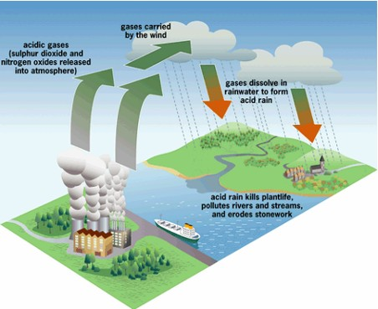

-organic matter when it is burned releases **OXIDES** (chemicals with oxygen)

Ex.) Carbon Di**oxide** (C**o2**)

Sulphur Di**oxide** (S**o2**)

Sulphur Tri**oxide** (S**O3**)

Nitrogen Di**oxide** (n**O2**)

-these oxides mix with moisture and water in the air and can form different compounds and eventually come down in the rain, snow, and sleet

What are the four types of reactions that we have in the air?

*Water (Clouds) What is produced?*

1. _________ + H20(l)  _____________

2. _________ + H20(l)  _____________

3. _________ + H20(l)  _____________

4. _________ + H20(l)  _____________

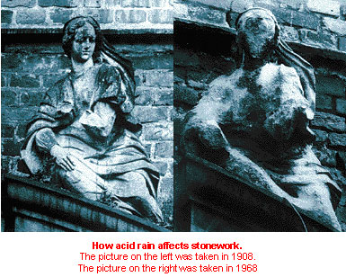2. Acid precipitation, commonly called ______________________, cause an estimated $____________________ in damages a year.

3. What are 4 commonly associated problems with acid precipitation?

1. _______________________________________

2. _______________________________________

3. _______________________________________

4. _______________________________________

**International Agreements**

-cars and other industrial processes that burn fossil fuels produce oxides which cause acid rain

-In ____________, Canada and U.S. agreed to reduce industrial exhaust by _______, and exhaust emissions from cars built before 1998 were to be reduced by ___________.

4. What is one major effect that acid rain had on terrestrial ecosystems?

**Be specific!!**

5. Leaching is a process in which chemicals are drawn through a system because of the movement of water. What problems were associated with leaching of acidic rain water?

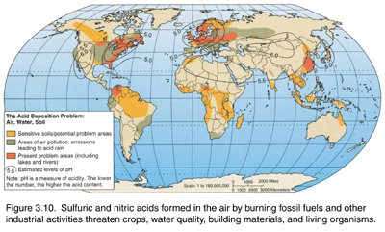

**Using Chemistry to Control Acid Effects**

-in order to get rid of a STRONG ACID, we can cancel it strength with a __________________________

-the term used to describe the process in which an acid is neutralized by a base or a base is neutralized by an acid is called _____________________________

-two products that will be produced in the reaction between an acid and a base will be ___________ and ______________

***acid + base Salt + Water***

E.g. **Hydrochloric acid + sodium hydroxide sodium chloride + water**

E.g. **Antacids** are mild bases that combat excessive stomach acid which has a usual acidity of about 2

E.g. **One of the major problems** that occurred in Ontario was that hundreds of lakes were testing positive for high levels of acid in the water. The government’s solution was to add a large level of calcium carbonate (limestone) to the lakes.

1. Why would the government want to do this? What would it help in doing?

2. This process is called __________________________________

3. Although this plan was successful, it had some problems associated with it. What were three problems with this plan? *(see pg. 209 for this one)*

1.

2.

3.

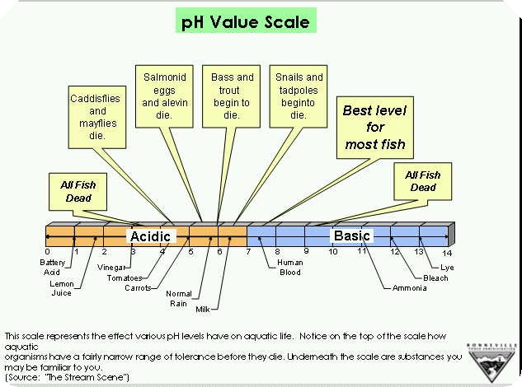

4. Although we have acid rain in Alberta and the other Western provinces we don’t have the same problem with acidic lakes like Ontario. Why would this be? What is different about our lakes in Alberta and the other Western provinces?

*(Pg. 207)*

**Using Chemistry to Control Harmful Emissions**

-the most effective way of controlling acid precipitation is to control the harmful emissions that cause it

**-Two ways to control these emissions is to use:**

**1. Catalytic Converter**

1. What is the purpose of a **Catalytic Converter**? What does it do?

2. What is a **Catalyst**? Why is it important for this process?

1. While they work well, what are some major drawbacks with

**Catalytic Converters**?

**2. Scrubbers**

-most factory emissions burn chemicals which release a large amount of oxides into the air. In order to reduce the amount of emissions leaving the factories through exhaust towers, the material can be treated.

1. What is a **Scrubber**? What is it used for?

2. Scrubbers use something called a **Sorbent**. What is a Sorbent?

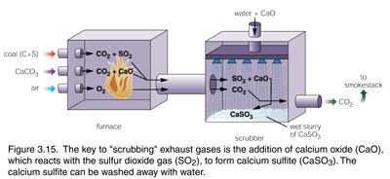

3. **COBRA**, a newer type of scrubber, has the ability to remove many harmful emissions. What percentage of Nitrogen Oxides did it remove and what percentage of Sulfur Dioxides?

Nitrogen Oxides = ______% Sulfur Dioxides = ______%