Square Roots Unit End Assignment

Name: ____________________ Date: _______________ Total = /30

Can I determine the square root of perfect squares?

**1.** Use each diagram to determine the value of the square root.

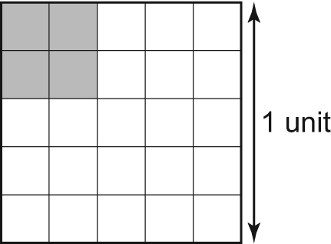**a)**  **b)** 

/2

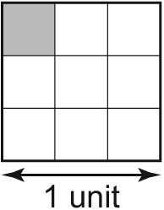

**2.** Which numbers below are perfect squares? How do you know?

/4

**a)**  **b)** 2.89 **c)**  **d)** 0.004

**3.** Calculate the number whose square root is:

/4

**a)**  **b)** 1.6 **c)** 0.92 **d)** 

**4.** Determine the value of each square root.

/5

**a)**  **b)**  **c)**  **d)**  **e)**  

**5.** The area of a square garden is 12.25 m2.

**a)** Determine the perimeter of the garden.

/2

**b)** The owner decides to put a gravel pathway around the garden. This reduces the area of

the garden by 4.96 m2. What is the new side length of the garden?

/2

Can I determine the approximate square root of imperfect squares?

**6.** Use benchmarks to approximate each square root to the nearest tenth.

**a)**  **b)**  **c)**  **d)** 

/4

**7.** 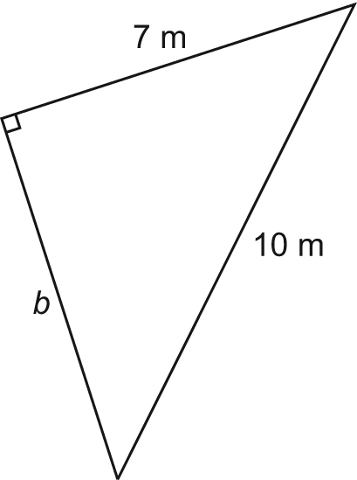In each triangle, determine the unknown length to the nearest tenth of a unit where necessary.

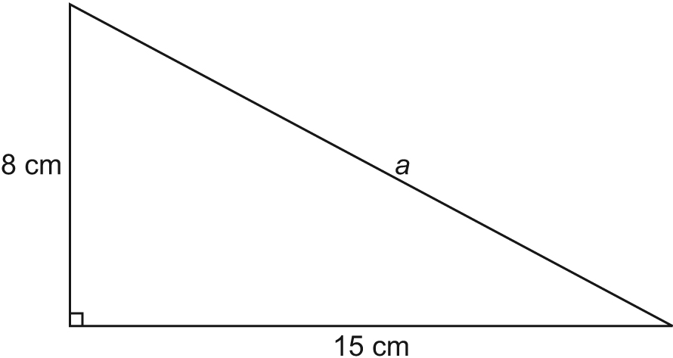**a)** **b)**

c

/4

**8.** A flag pole is 10m high and is supported by two guy wires connected half way up.  If each of

the wires is connected 4m from the base of the flagpole, what is the total length of the wire

that is needed to support the structure? Round your answer to the tenth.



/3