Optical Telescopes

Reflecting
-cheaper because mirrors are easy to build
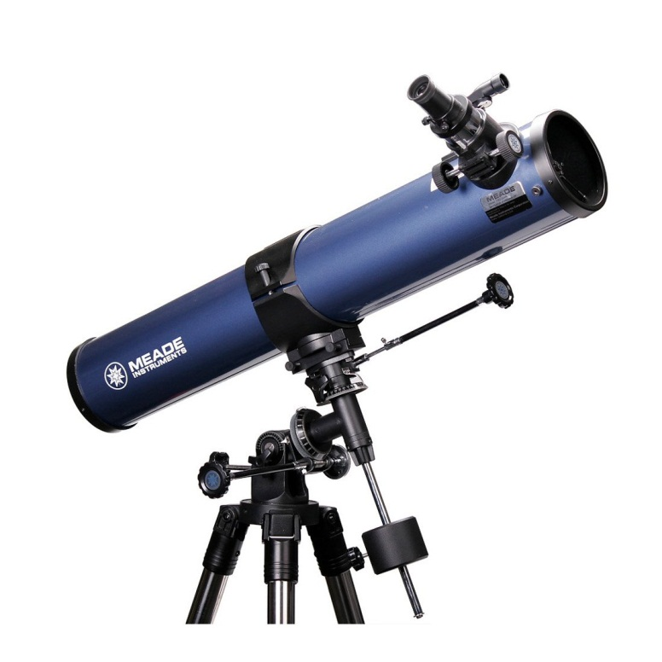
-wide tube to let in more light

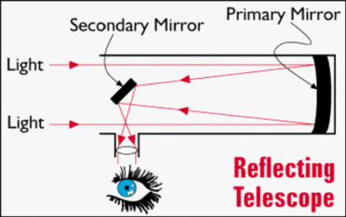
Refracting
-expensive because lenses made from fine ground glass
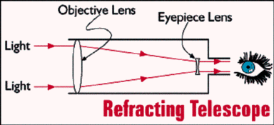
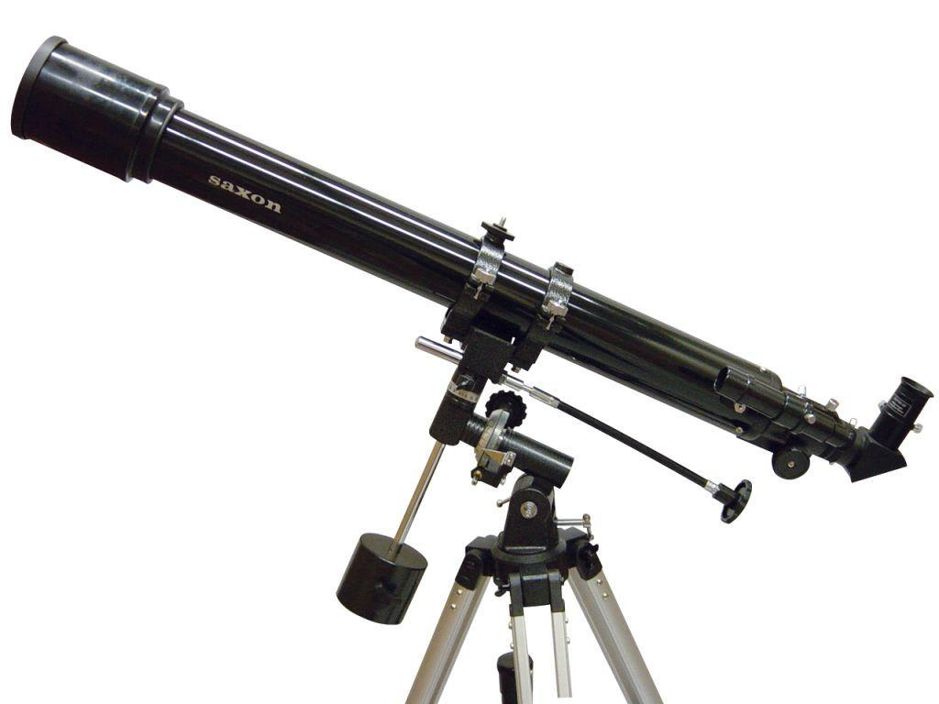
-longer tube to align focal lengths for clarity

