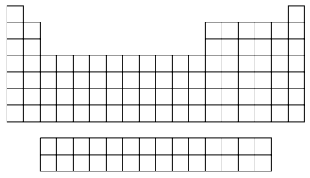

**Name: __________________________**

**Date: _____________________**

Fill in everything you know about the periodic table of elements including information such as: element name and symbol, atomic number, family names, relationship between elements, who created the original periodic table of elements, etc.

**Outcome #1: Describe the chemical nature of elements.**

* ***Can I describe the relationship between the structure of atoms in each group and the properties of elements in that group?***
* ***Can I understand the origins of the periodic table and relate patterns in the physical and chemical properties of elements to their positions in the periodic table?***

**Periodic Table of Elements**