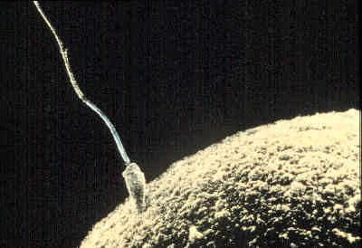

**Nature vs Nurture**

**Homozygous (purebred)**

**Heterozygous (hybrid)**

**Genotypes**

**Alleles**

**recessive**

**Dominant**

**Heredity is:**

**Genetics is:**

**Gametes**

**Human egg**

**# chromosomes:**

**Human sperm**

**# chromosomes:**

**Human Zygote**

**# chromosomes:**

**Genes**

**Genes**