Extra Practice 7 Name: __________________
Master 7.29
Lesson 7.7 Identifying Types of Symmetry on the Cartesian Plane
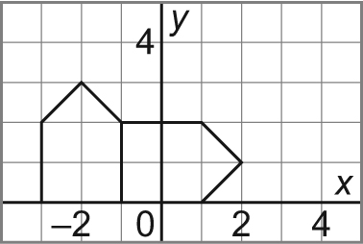
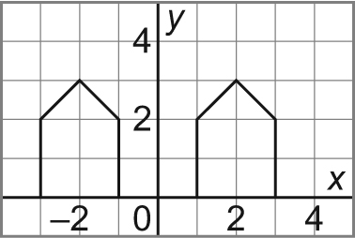
1. For each pair of shapes, determine whether they are related by a Reflection (Re),
by Rotational Symmetry (Ro), or by Translation (Ta).
Describe the symmetry, if any.
a) b)

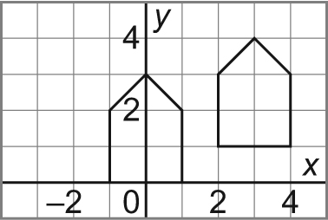
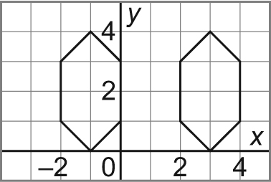
c) d)

2. Which of the rectangles A, B, C, D is related to rectangle X:
a) by rotational symmetry about the origin?

b) by rotational symmetry about one of the vertices of rectangle X?

c) by line symmetry?
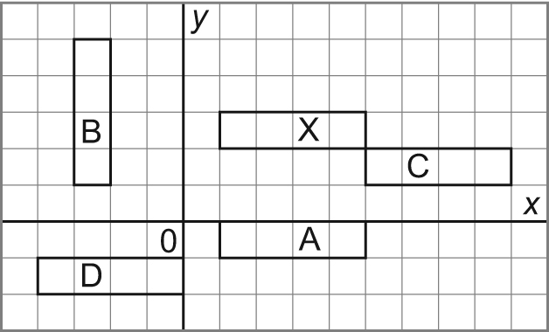
3. Identify and describe the types of symmetry in the petal shapes.
a) b) c) d) e)

Rotational
Line Symmetry

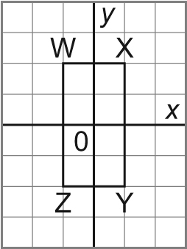
4. Draw the image of quadrilateral WXYZ after each transformation.
Write the coordinates of each shape formed by quadrilateral WXYZ
and its image. Describe the symmetry in each of these shapes.
a) reflection in the x-axis
b) rotation 90° clockwise about the origin
c) rotation 90° clockwise about the point (1, 0)
d) translation 1 square right and 1 square down

d.
c.
b.
a.

