Extra Practice 6 Name: _______________
Master 7.28
Lesson 7.6 Line and Rotational Symmetry
1. Which polygons have rotational symmetry? State the order of rotation and the angle of rotation symmetry for each.
a) b) c) d)

2. Draw the rotation image for each rotation of quadrilateral ABCD.
Rotate quadrilateral ABCD clockwise about vertex D by:
a) 60° b) 120° c) 180°
d) 240° e) 300°

Consider the larger shape formed by quadrilateral ABCD and these rotation images. Describe the symmetry of this shape.

3. What is the order of rotation and the angle of rotation symmetry, if any, for:
a) an equilateral triangle b) a regular polygon with 9 sides

c) a kite that is not a rhombus d) the plus sign +

4. Plot the kite FISH on a coordinate grid.
The vertices of FISH are F(3, 4), I(5, 2), S(3, 1), H(1, 2).
Rotate the kite FISH:
a) 90° clockwise about vertex F
b) 180° about vertex F
c) 270° clockwise about vertex F
Draw each rotation image.
Look at the shape formed by the kite and its rotation images.
Write the coordinates of this shape. F( , ) I( , ) S( , ) H( , )
Describe any rotational symmetry in this shape.

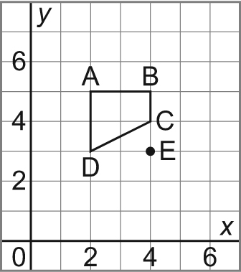
5. Draw the rotation image for each
transformation of quadrilateral ABCD.
a) 180° about vertex B
b) 90° clockwise about vertex A
c) 90° counterclockwise about point E

