Extra Practice 5 Name: _________________
Master 7.27
Lesson 7.5 Reflections and Line Symmetry
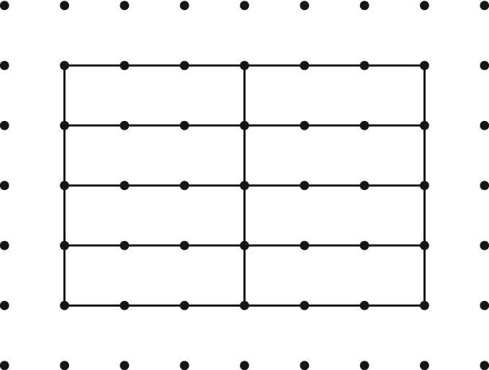
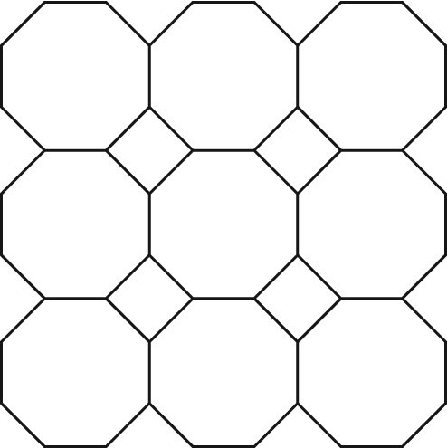
1. Draw in the lines of symmetry in each design.
a) b)

2. Draw the image of ΔPAM after each reflection below.
Write the coordinates of the larger shape formed by ΔPAM and its reflection images.
Draw the lines of symmetry of the larger shape.

a) Reflect ΔPAM in the horizontal line passing through 2 on the y-axis.
b) Reflect ΔPAM in the vertical line passing through 5 on the x-axis.
c) Reflect ΔPAM in the oblique line passing through the points (2, 2) and (5, 5).
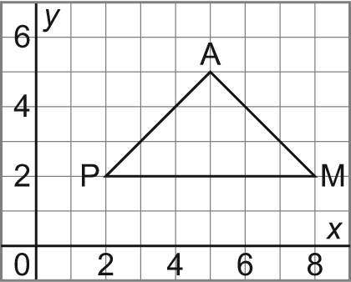
a) b) c)

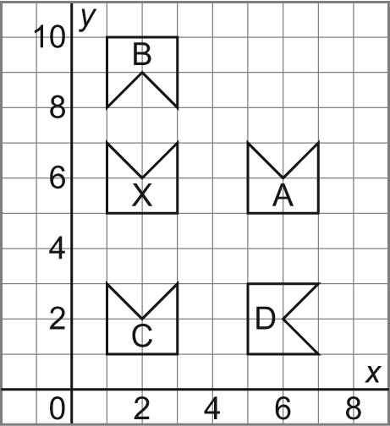
3. Identify the shapes that are related to the shape X by a line of reflection.
Describe the line of symmetry in each case.
________________________________________________
________________________________________________
_________________________________________________

