Electric Devices and Efficiency

Name: ______________________ Date: ________ Class: _______

General Outcome #3: Examine the power and efficiency of various devices.
- Can I calculate the amount of energy that a device uses?
- Can I apply the concepts of conservation of energy and efficiency to different devices?

100% efficient would mean that all input energy (electric energy the device took in) would be converted into the energy produced by the device. Much of the electric energy take in by a device is given off as waste heat.
e.g. A 100% efficient light bulb would convert all of the electric energy it took in into light.

Is it possible to have a 100% efficient device? Why or why not?

Calculating Efficiency

Efficiency = useful energy output x 100%
total energy input

*To determine total energy input you can use the formula:

Power = Energy in Joules P = E This formula can be rearranged:
Time in Seconds t E = Pt

Example:

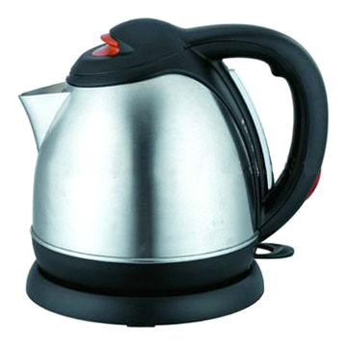
A 1000 Watt electric kettle takes 4 minutes to boil water. If it takes 1.96 x 10⁵ Joules of energy to heat the water, what is the efficiency of the kettle?

Efficiency = useful energy output x 100%
total energy input

What you know:
Power=1000W Useful energy output=1.96 x 10⁵ Joules
Time = 4 minutes (needs to be converted to seconds)
*You need to find out the total energy input.
*You also need to calculate the efficiency.

Calculations:

