Materials needed in partnership:
- 4 strands of liquorice (2 of one colour and 2 of another colour)
- 24 mini-marshmallows (6 pink, 6 green, 6 yellow, 6 peach)
- 2 lengths of yarn at least four finger widths longer than two strand of liquorice)
- 12 paperclips
- 1 baggie to store materials (your names need to be on the baggie)
Instructions:
- Cut each strand of liquorice into 12 pieces approximately equal in length.
- Thread alternate colours of liquorice into a chain until you have 24 pieces total. Tie your yarn in a knot at each end piece of liquorice so that the chain stays together. You can use tape also.
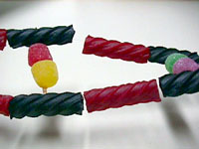
- Repeat to create your second chain.
- Line up the two chains side by side so opposite pieces are the same colour.
- Pair your pink and green marshmallows together.
- Pair your yellow and peach marshmallows together.
- Attach your marshmallow pairs between the liquorice chains with the paperclip (straighten it and fold it in half to use as a pin). These pairs attach on the second link of the liquorice chain. Repeat process until all marshmallow pairs are attached to the chains.
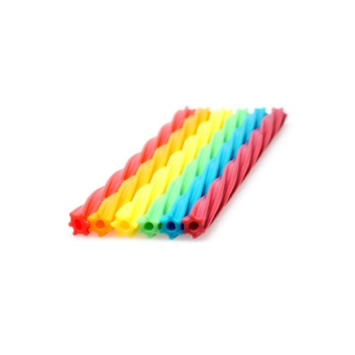
DNA Model Guiding Questions
Name: _________________________________ Date: __________________
- What does one colour of liquorice represent?

- What does the other colour of liquorice represent?

- What does each colour of marshmallow represent?
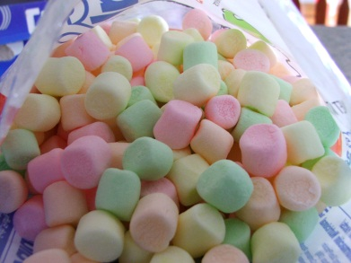
- Green
- Pink
- Yellow
- Peach

- Why is green only attached to pink marshmallows?

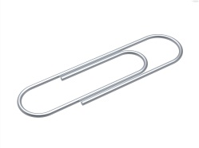
- Why is yellow only attached to peach marshmallows?

- What do the paper clips represent?

- What is a nucleotide and what are its components?

- DNA is the short form of this word:

- Describe the double helix structure of DNA.

- Who discovered this double helix structure?

- What are chromosomes?

