**You’ve Got the Cutest Little Baby Face**

When only considering a hundred traits, you can produce 1030 different genetic combinations among their offspring (and each kid will be different!!!)

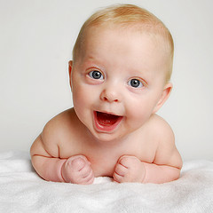

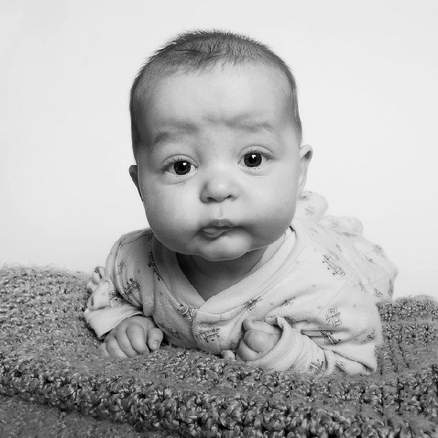

**Objective: Explain the link between reproduction and heredity.**

To show the tremendous variety possible when you begin to combine genes, you and a classmate will establish the genotypes (genetic make-up) and phenotypes (physical characteristics) for two potential offspring.

These traits may be expressed as phenotypes in a variety of ways. Which of the two alleles you donate in your gamete is totally random, like flipping a coin.

**Instructions**

1. Determine the gender of the baby:

As in real life, we will let the father flip the coin to determine sex.

Head = Y Chromosome (male)

Tail = X Chromosome (female)

2. Flip a coin to determine the alleles for the rest of the 26 traits. Fill in the chart as you go.

Remember: Heads dominant trait (upper case)

Tails recessive trait (lower case)

3. Now draw and colour your baby as accurately as possible using all of the genotypes from your chart.

4. Next we will have the cutest baby contest!!

|  |  |  |  |  |  |
| --- | --- | --- | --- | --- | --- |
| Trait # | Trait | Allele from Mother | Allele from Father | Baby’s Genotype | Baby’s Phenotype |
| 1. | Hair Type |  |  |  |  |
| 2. | Widow’s Peak |  |  |  |  |
| 3. | Hair Color (1) |  |  |  |  |
| 4. | Hair Color (2) |  |  |  |  |
| 5. | Eyebrow Type |  |  |  |  |
| 6. | Eyebrow Separation |  |  |  |  |
| 7. | Eyelashes |  |  |  |  |
| 8. | Eye Size |  |  |  |  |
| 9. | Eye Shape |  |  |  |  |
| 10. | Eye Slant |  |  |  |  |
| 11. | Eye Color |  |  |  |  |
| 12. | Mouth Length |  |  |  |  |
| 13. | Lips |  |  |  |  |
| 14. | Dimples |  |  |  |  |
| 15. | Hapsburg Lip |  |  |  |  |
| 16. | Nose Size |  |  |  |  |
| 17. | Nose Shape |  |  |  |  |
| 18. | Nostril Shape |  |  |  |  |
| 19. | Freckles on Cheeks |  |  |  |  |
| 20. | Freckles on Forehead |  |  |  |  |
| 21. | Face Shape |  |  |  |  |
| 22. | Chin Shape |  |  |  |  |
| 23. | Cleft Chin |  |  |  |  |
| 24. | Earlobe Attachment |  |  |  |  |
| 25. | Darwin’s Ear point |  |  |  |  |
| 26. | Hairy Ear |  |  |  |  |

**Baby Face Data Sheet**

Parents Name : ___________________________ and ____________________________

Child’s Name : ____________________________ Gender: ________________________

|  |  |  |
| --- | --- | --- |
| Inherited Traits | | |
| 1. Hair Type | | |
| Curly (CC) | Wavy (Cc) | Straight (cc) |
|  |  |  |

|  |  |
| --- | --- |
| Inherited Traits | |
| 1. Widow’s Peak | |
| Present (WW, Ww) | Straight (ww) |
|  |  |

|  |  |  |  |
| --- | --- | --- | --- |
| Inherited Traits | | | |
| 1. Hair Colour | | | |
| Hair colour is produced by several different genes (a polygenic trait -“poly” means many). It will take four tosses by each parent to determine the genotype of the child.  *flip your coins four times each and record each toss in the box below. | | | |
| Dominant | | Recessive | |
|  | |  | |
| 8 Dominant = black hair  7 Dominant = very dark brown  6 Dominant = dark brown  5 Dominant = brown  4 Dominant = light brown | | 3 Dominant = brown mixed w/ blond  2 Dominant = blond  1 Dominant = very light blond  0 Dominant = almost white | |
| **Inherited Traits** | | | |
| 1. Hair Colour: Red Tint (H – heads, T – tails) | | | |
| Very Dark Red (HH) | Light Red (HT) | | No Red (TT) |
| ** however, brown or black hair will not show the red. You can only see the red if the child is light brown or lighter (4 or lower) | | | |

|  |  |
| --- | --- |
| Inherited Traits | |
| 1. Eye Brows | |
| Bushy (BB, Bb) | Fine (bb) |
|  |  |

|  |  |
| --- | --- |
| Inherited Traits | |
| 1. Eyebrow Separation | |
| Not connected (SS, Ss) | Connected (ss) |
|  |  |

|  |  |
| --- | --- |
| Inherited Traits | |
| 1. Eyelashes | |
| Long (LL, Ll) | Short (ll) |
|  |  |

|  |  |  |
| --- | --- | --- |
| Inherited Traits | | |
| 1. Eye Size | | |
| Large (LL) | Medium (Ll) | Small (ll) |
|  |  |  |

|  |  |
| --- | --- |
| Inherited Traits | |
| 1. Eye shape | |
| Almond or wide (AA, Aa) | Round or Narrow (aa) |
|  |  |

|  |  |
| --- | --- |
| Inherited Traits | |
| 1. Eye Slantedness | |
| Horizontal (BB, Bb) | Upward Slant (bb) |
|  |  |

|  |  |
| --- | --- |
| Inherited Traits | |
| 1. Eye Colour | |
| Eye color is produced by several different genes (a polygenic trait -“poly” means many). Each parent tosses the coin twice. The first gene is for the pigment in front of the iris and second gene is for the pigment behind the iris. | |
| Toss #1 | Toss #2 |
| _______________ _____________ | ___________ ____________ |
| HH HH – Dark Brown  Ht HH – Brown w/ green fleck  Ht Ht - Brown  tt HH - Green  tt tt – Light Blue | HH Ht – Dark Brown  HH tt – Brown  Ht tt – Gray – blue  tt Ht – Dark blue |

|  |  |  |
| --- | --- | --- |
| Inherited Traits | | |
| 1. Mouth Length | | |
| Long (LL) | Average (Ll) | Short (ll) |
|  |  |  |

|  |  |
| --- | --- |
| Inherited Traits | |
| 1. Lips | |
| Thick (LL, Ll) | Thin (ll) |
|  |  |
| Inherited Traits | |
| 1. Dimples | |
| Present (AA, Aa) | Absent (aa) |
|  |  |

|  |  |  |
| --- | --- | --- |
| Inherited Traits | | |
| 1. Hapsburg Lips: narrow lower jaw with a protruding underlip | | |
| Very Protruding (LL) | Slightly Protruding (Ll) | Absent (ll) |
|  |  |  |

|  |  |  |
| --- | --- | --- |
| Inherited Traits | | |
| 1. Nose Size | | |
| Big (LL) | Medium (Ll) | Small (ll) |
|  |  |  |

|  |  |
| --- | --- |
| Inherited Traits | |
| 1. Nose Shape | |
| Rounded (AA, Aa) | Pointed (aa) |
|  |  |

|  |  |
| --- | --- |
| Inherited Traits | |
| 1. Nostil Shape | |
| Rounded (DD, Dd) | Pointed (dd) |
|  |  |

|  |  |
| --- | --- |
| Inherited Traits | |
| 1. Freckles on Cheek | |
| Present (BB, Bb) | Absent (bb) |
|  |  |

|  |  |
| --- | --- |
| Inherited Traits | |
| 1. Freckles on Forehead | |
| Present (BB, Bb) | Absent (bb) |
|  |  |

|  |  |
| --- | --- |
| Inherited Traits | |
| 1. Face Shape | |
| Round face (BB, Bb) | Square face (bb) |
|  |  |

|  |  |
| --- | --- |
| Inherited Traits | |
| 1. Chin Shape | |
| Prominent (BB, Bb) | Less Prominent (bb) |
|  |  |

|  |  |
| --- | --- |
| Inherited Traits | |
| 1. Cleft Chin | |
| Present (BB, Bb) | Absent (bb) |
|  |  |

|  |  |
| --- | --- |
| Inherited Traits | |
| 1. Ear lobe Attachment | |
| Free (BB, Bb) | Attatched (bb) |
|  |  |

|  |  |
| --- | --- |
| Inherited Traits | |
| 1. Darwin’s Ear Point | |
| Present (BB, Bb) | Absent (bb) |
|  |  |

|  |  |
| --- | --- |
| Inherited Traits | |
| 1. Hairy Ears | |
| *ONLY for a male child *Father determines if the gene is passed. Heads they have it, tails they do not. | |
| Present (Heads) | Absent (Tails) |
|  |  |

C:\Documents and Settings\dolezalc\Local Settings\Temporary Internet Files\Content.IE5\5PVDMZD9\MC900104454[1].wmf