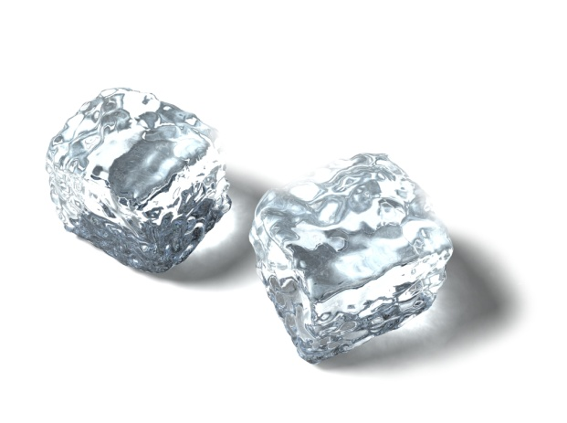C:\Users\lgratton\AppData\Local\Microsoft\Windows\Temporary Internet Files\Content.IE5\SKPE0CDS\MC900278998[1].wmf

Name: ____________

Date: __________

* ***Can I differentiate between a physical and a chemical reaction?***

Definition:

Examples:

Indicators of a Physical Change:

Illustration:

Definition:

Examples:

Indicators of a Chemical Change:

Illustration: