Extra Practice 5
Lesson 4.5: Using Graphs to Estimate Values
1. This graph represents a linear relation.
a) Determine the value of x for each value of y.
i) y = 1 ii) y = 3 iii) y = 0
b) Determine the value of y for each value of x.
i) x = 2

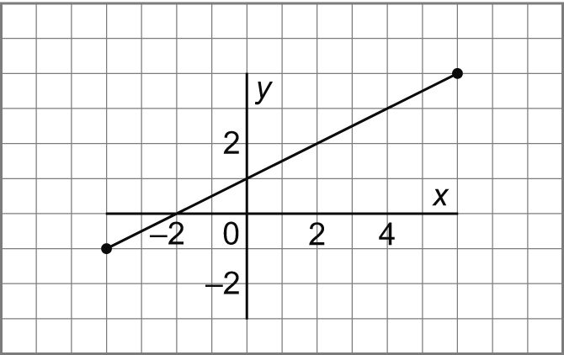
ii) x = 8

iii) x = –6

2. This graph represents a linear relation.
a) Determine the value of x for each value of y.
i) y = 3 ii) y = –2
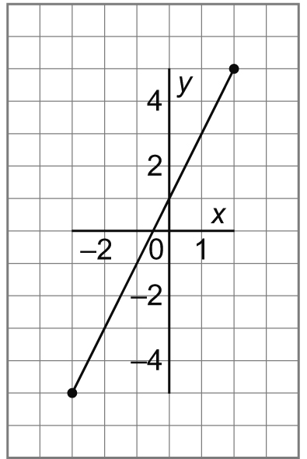
iii) y = 7

b) Determine the value of y for each value of x.
i) x = 0 ii) x = –2

iii) x = –4

3. This graph represents a linear relation.
a) Determine the value of x for each value of y.
i) y = 2 ii) y = 0

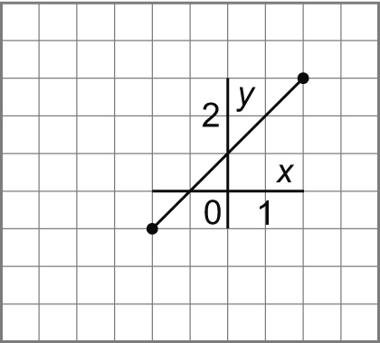
iii) y = 5

b) Determine the value of y for each value of x.
i) x = 0 ii) x = 3

iii) x = –5

4. The graph shows how the cost of a long distance
call changes with the time for the call.

a) Estimate the cost of a 7-min call.
Is this interpolation or extrapolation? Explain.

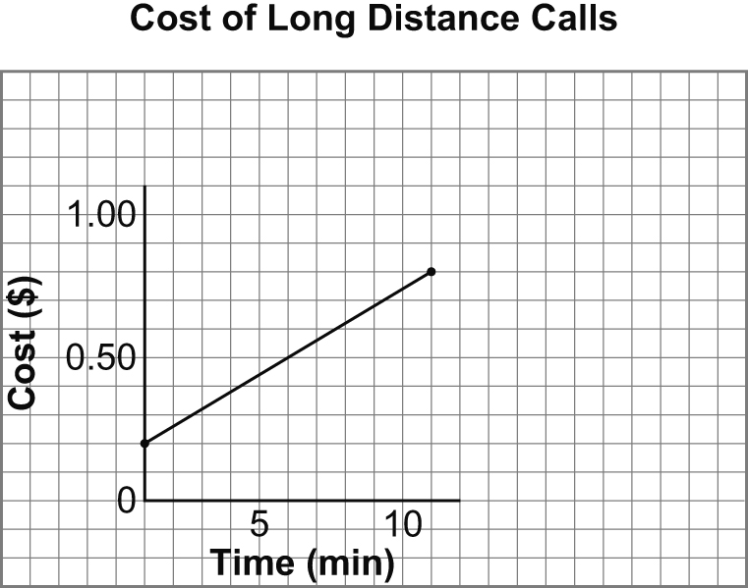

b) The cost of a call was $1.00.
Estimate the time for the call.

c) The cost of a call was $1.50.
Estimate the time for the call.

