Extra Practice 4
Lesson 4.4: Matching Equations and Graphs
1. Match each equation with a graph on this grid.
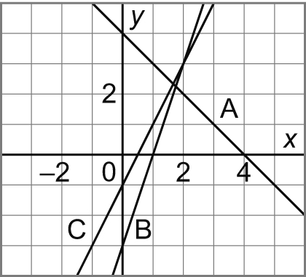
a) y = 2x – 1
b) y = –x + 4
c) y = 3x – 3

2. Match each equation with a graph on this grid.
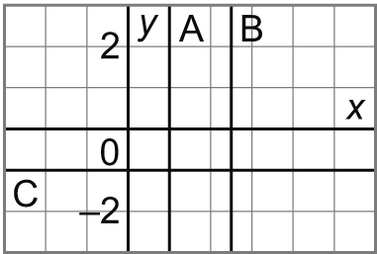
a) y = – 1
b) 0 = –x + 1
c) 2 = 2x – 3

3. Match each equation with a graph on this grid. Justify your answers.
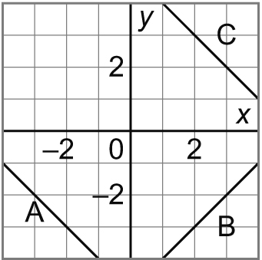
a) x + y = 5
b) x – y = 5
c) x + y = –5

4. Which equation describes this graph? Justify your answers.
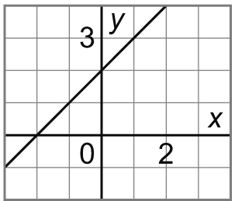
a) y = x + 2
b) y = –x + 2
c) y = x – 2

5. Which equation describes this graph? Justify your answers.
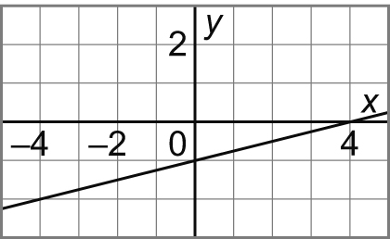
a) x – y = 4
b) x – 4y = 4
c) 4x – y = 1

