Extra Practice 3
Master 4.22
Lesson 4.3: Another Form of the Equation for a Linear Relation
1. Does each equation describe a vertical, a horizontal, or an oblique (angled) line?
Describe each vertical or horizontal line.
a) y = 4 ________________ b) 2x + 5 = 7 ___________________

c) 2x – y = 6 ____________ d) 3y + 9 = 0 ___________________
2. Which equation below describes each graph?
a) b)
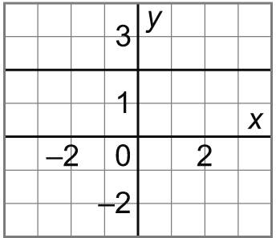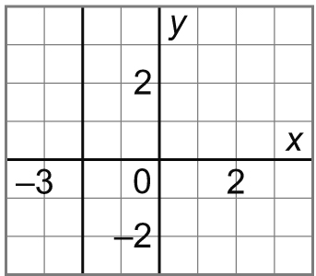
i) x = 2 ii) x = –2
iii) y = 2 iv) y = –2

x | y

3. The sum of two numbers is 8. Let x and y represent
the two numbers.
a) Create a table for 5 different values of x.

b) Graph the data. Should you join the points?

c) Write an equation that relates x and y.

4. Graph each line. Explain your work.
a) x = 4 b) 2y = 6

c) y – 2 = –6 d) 2x + 3 = 8
5. For each equation below:
- Make a table for the given values of x.
- Graph the equation.
a) 3x + y = 3; for x = –2, 0, 2
b) x – 2y = 8; for x = –2, 0, 2

